Project Documentation

* Project Title : **Cook Book**-*Your Virtual Kitchen Assistant*
* Team ID : NM2025TMID40038
* Team leader : AARTHEE.C
* [E-mail : [sac2427bca5245@ssacollegechennai.com](mailto:sac2427bca5245@ssacollegechennai.com)]

Team Members:

* AMALA.J
* [E-mail : sac2427bca5698@ssacollegechennai.com]
* ANISH MALIKA.A
* [E-mail: anishmalika20@gmail.com]
* ASMA BEGUM.I
* [E-mail : [sac2427bca5212@ssacollegehennai.com](mailto:sac2427bca5212@ssacollegehennai.com)]

1. Introduction:

Cook Book-your virtual kitchen assistant is a smart app that help you plan and cook meals easily. It gives you step-by-step recipes, nutrition details ,and shopping lists to make cooking simple .You can search by ingredients ,get tips, and even use voice guidance while cooking .It’s like having your own personal chef and kitchen manager in one place.

2. Project Overview:

Purpose: To provide an easy-to-use digital cooking guide with step-by-step recipes and tutorials.

Features:

* Search recipes from the collection
* Subscribe to the page for updates
* Detailed ingredients &step-by-step procedure
* Video tutorials for recipes
* Direct navigation to the home page

3. Architecture:

* Frontend: React.js with CSS or styling
* Backend: Node.js + Express.js(optional ,if subscription and feature implemented)
* Database :Mongo(optional for storing subscriptions and recipe data)
* Authentication :optional(if user login is added)

4. Setup Instructions:

* Install Node.js
* Install npm packages using ‘npm install’
* Run frontend using ‘npm start’
* Use Visual Studio Code for development

5. Folder Structure:

CookBook/

* |--public/ #Static assets(index.html icons)
* |--src/ #Source code
* | __components/ # Reusable UI components
* |__pages/ #Application pages
* |__Styles/ #CSS styles
* |__App.js #Main React App
* |__Index.js #Entry point
* |--Package.json #Project Dependencies
* |--README.md

6. Running the Application:

* npm start(Run fronted)
* Access application at <http://localhost3000>

7. API Documentation:

* GET/api/recipes->Fetch all recipes
* GET/api/recipes->Fetch single recipe with ingredients &procedure
* GET/api/videos/:id->Fetch video tutorial link
* POST/api/subscribe user to page updates
* GET/api/home->Direct navigation to home page

8. Authentication :

Currently optional .can be implemented if login/subscription requires secure access

9. User Interface:

* Landing page with recipe search
* Recipe page with ingredients and procedure
* Video tutorial page
* Home page for direct navigation
* Subscribe section

Demo image 1:

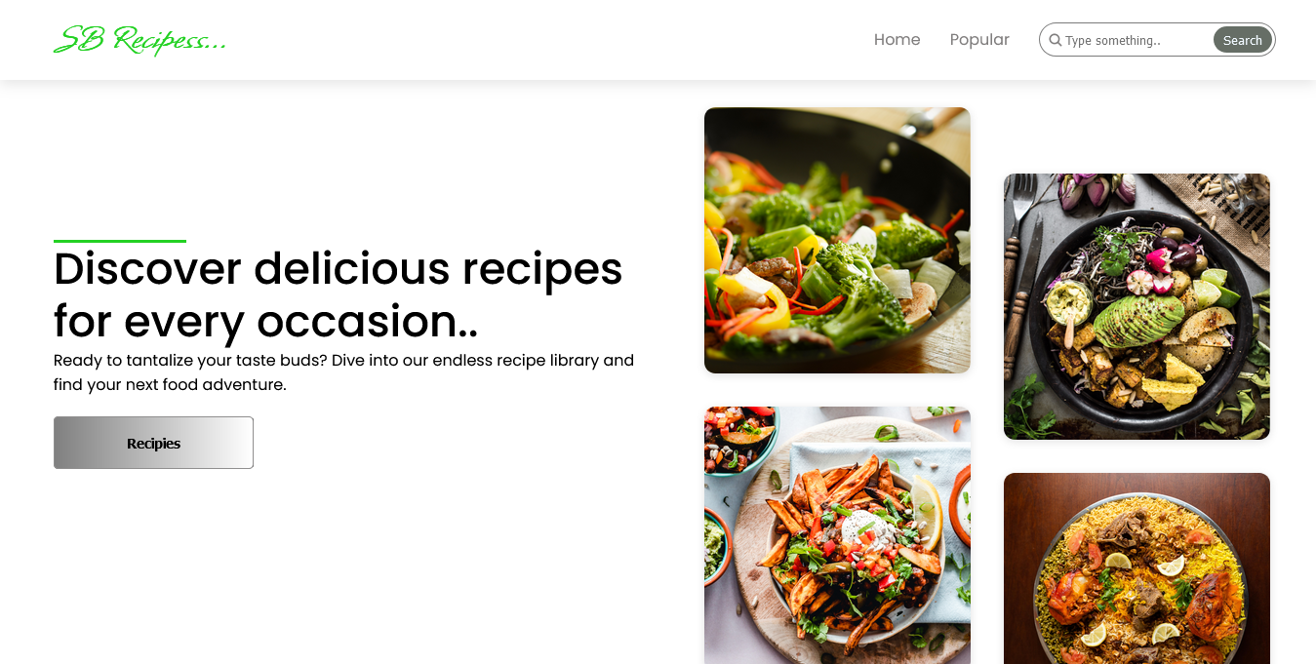

Demo image:

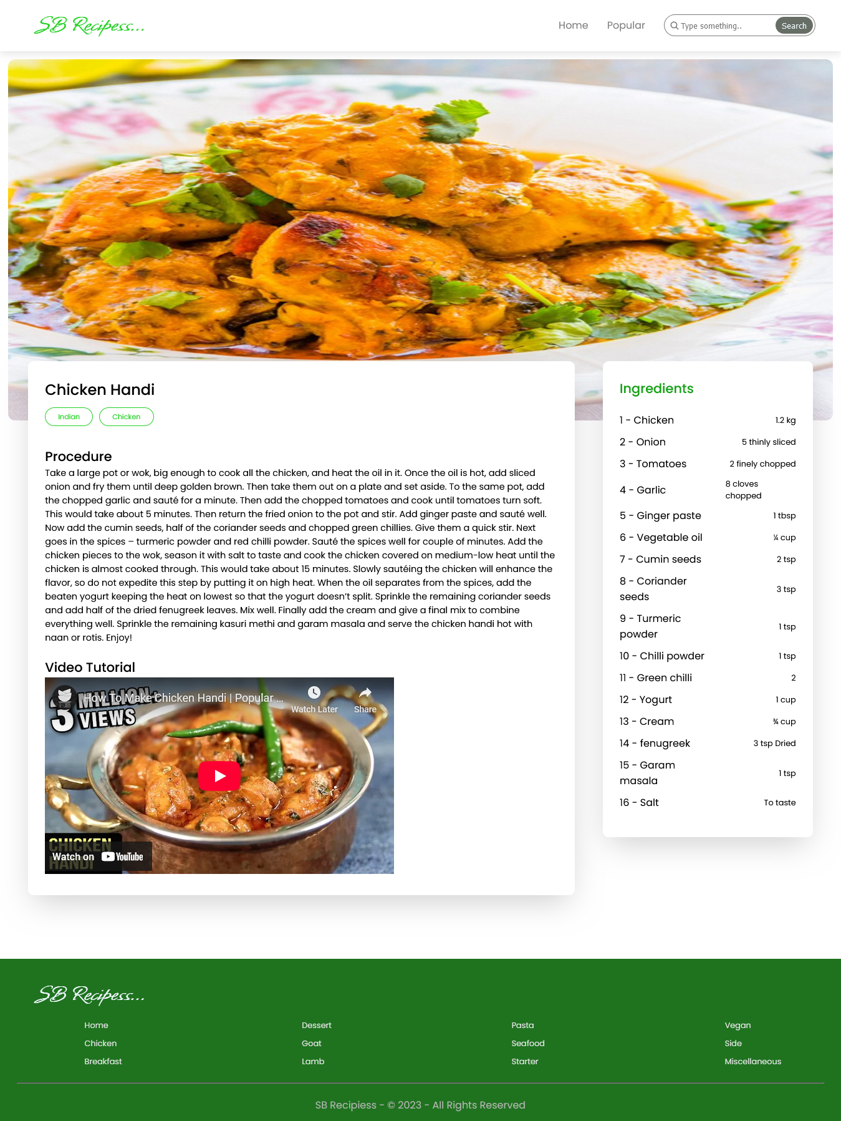

10. Testing:

* Manual testing of recipe search, subscription and video tutorial access
* Tools: Chrome Dev Tools, Postman(if APIs implemented)

11. Demo video link:

https://drive.google.com/file/d/1qYupIWtGvA6C_vDsFk9_XtxGEQ4ps2c8/view?usp=drive_link

12. Known Issues:

* Limited number of recipes in the initial version
* Requires internet connection for video tutorials

13. Future Enhancements:

* Add user accounts with personalized recipe collections
* AI-based recipe recommendations
* Voice-enabled cooking assistant
* Offline mode for saved recipes and videos